Jenkins Assignment:

* Open source Continuous Integration tool and automation server to monitor continuous integration and delivery.
* Jenkins follows Groovy Scripting
* It enables developers to continuously check in their code and analyze the post-build actions.
* The automation testers can use to run their tests as soon as the new code is added, or code is modified.
* **Plugins in Jenkins includes:**
* Gits
* Maven 2 Project
* HTML Publisher
* Copy Artcraft
* Join
* Green Balls
* Amazon EC2

Created the Instance:

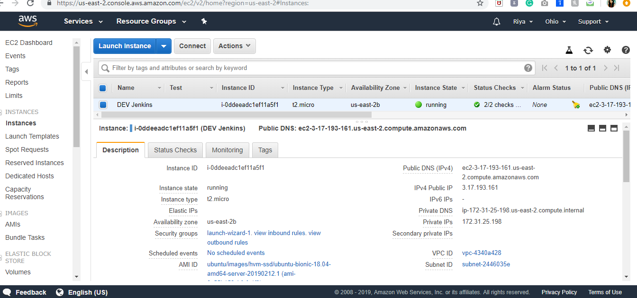

Download the .zip file of Jenkins window version:

Checking Instance on git bash:

Connect ubuntu with git bash : Priya@DESKTOP-C783A4B MINGW64 ~/Downloads

$ ssh -i Test-key.pem ubuntu@3.15.33.238

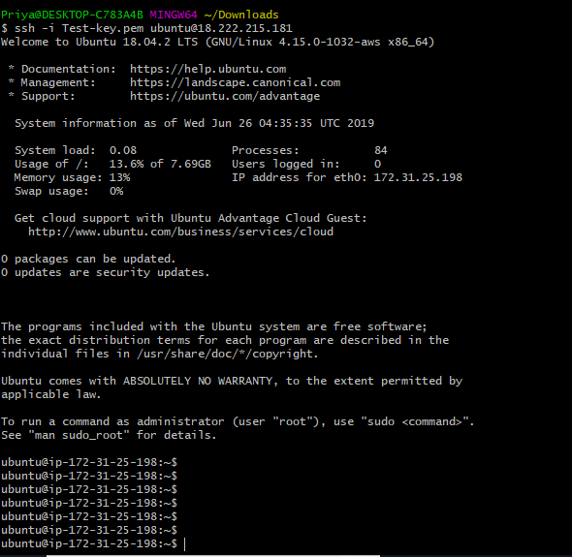

Setting up the Wireless connection:

Generate key **ssh-keygen** on both the terminal:

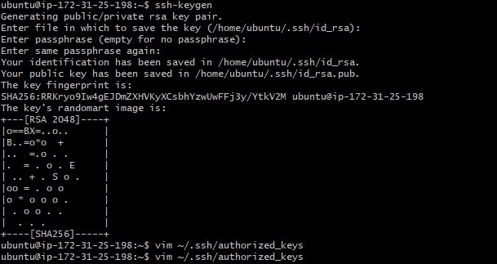

First get the public key from ubuntu and copy to instance open in git bash:

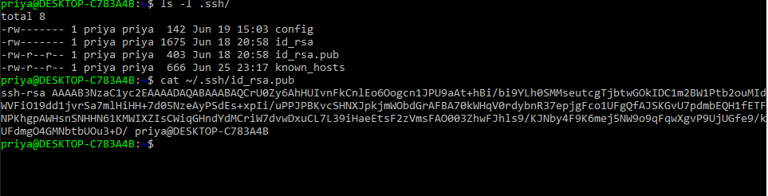

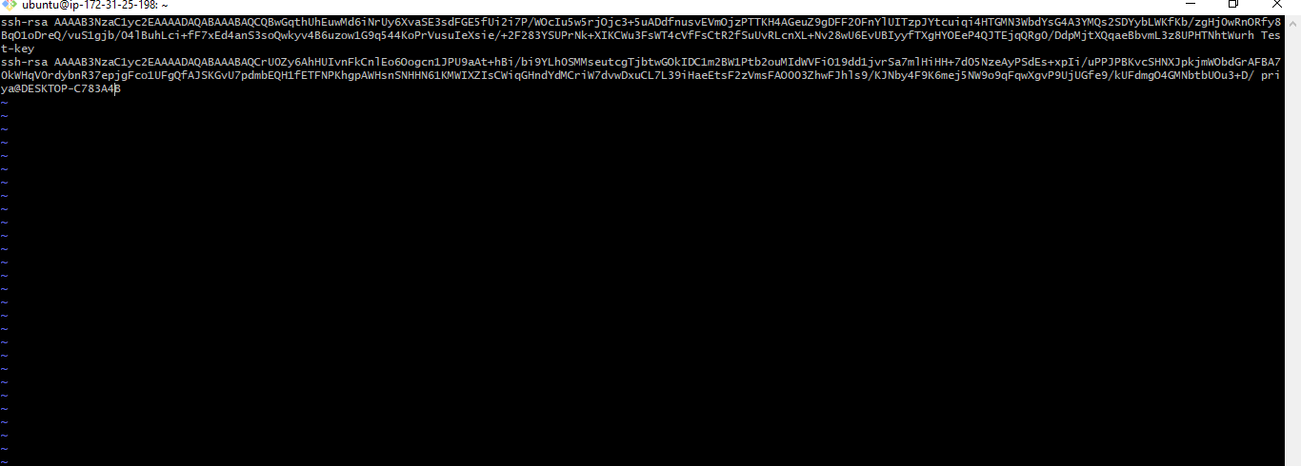

Now I am able to open the ubuntu using ssh only: which is a wireless connection:

Command eg: ssh ubuntu@3.15.33.238

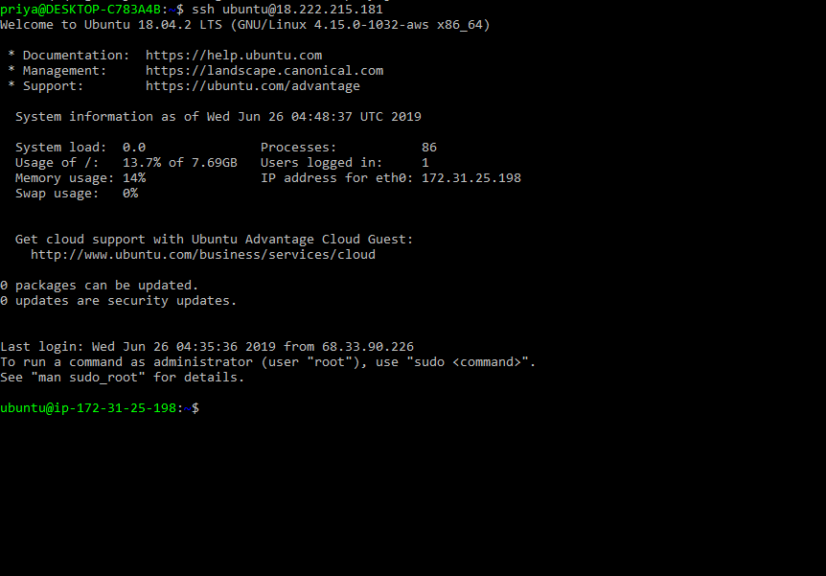

To check the location of ubuntu distribution and repository:

Copy the path first:

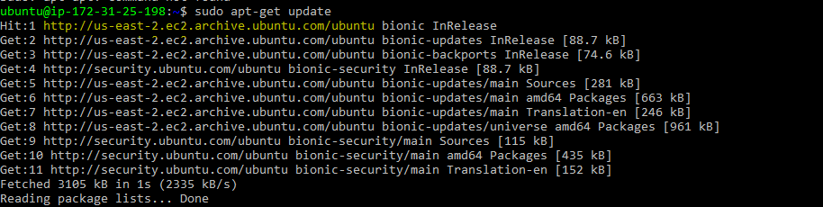

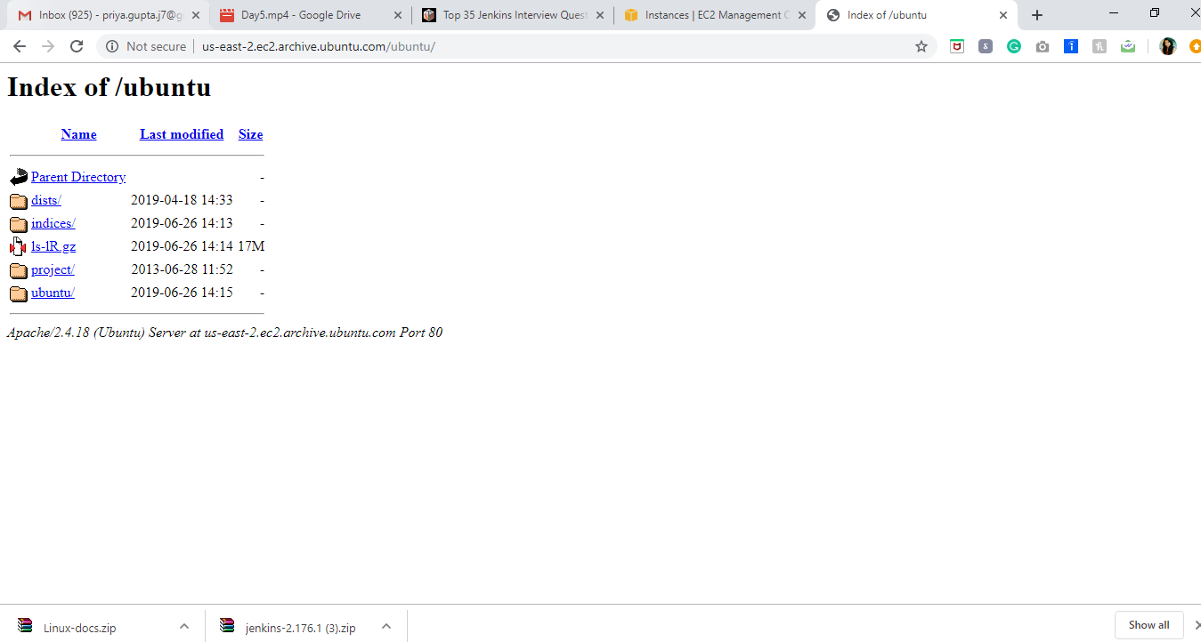

Install jdk: sudo apt-get install openjdk-8-jdk

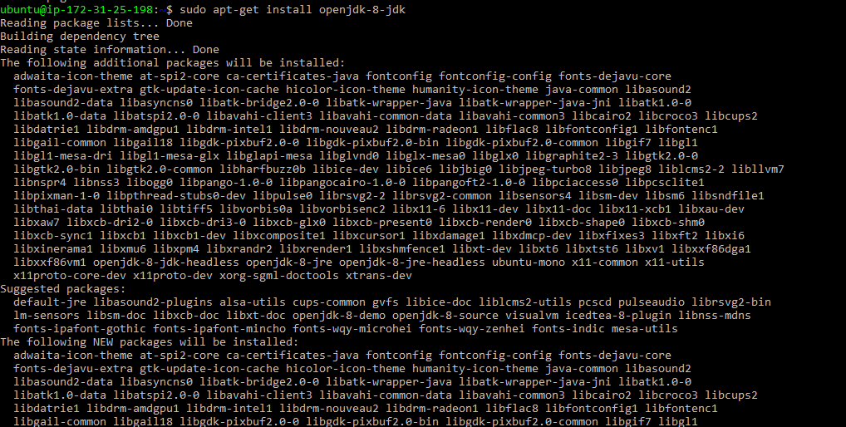

**Setting up the $JAVA_HOME**

* JAVA_HOME is a system environment variable which represent JDK installation directory.
* When you install JDK in your machine (windows, Linux or unix) it creates a home directory and puts all its binary (bin), library(lib) and other tools.
* In order to compile java program "javac" tool should be in your [PATH](http://javarevisited.blogspot.com/2011/10/how-to-set-path-for-java-unix-linux-and.html) and in order to get that in PATH we use JAVA_HOME environment variable.
* Many tools like ANT and web servers like tomcat use JAVA_HOME to find java binaries.

Check the path:



Command like echo $JAVA_HOME = $(which java)” | sudo tee -a /etc/environment

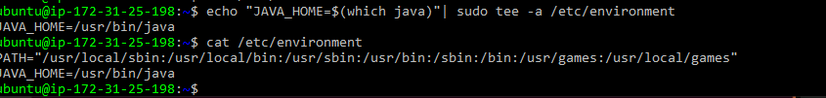  
**Run source command**

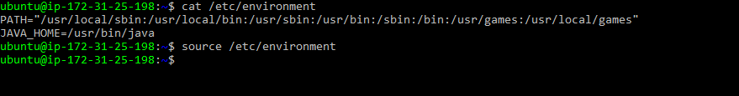

**Check the java_home setup path:**

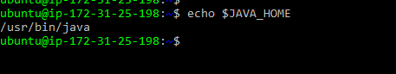

**Next step:**

**Run all the command required to Install Jenkins on ubuntu**

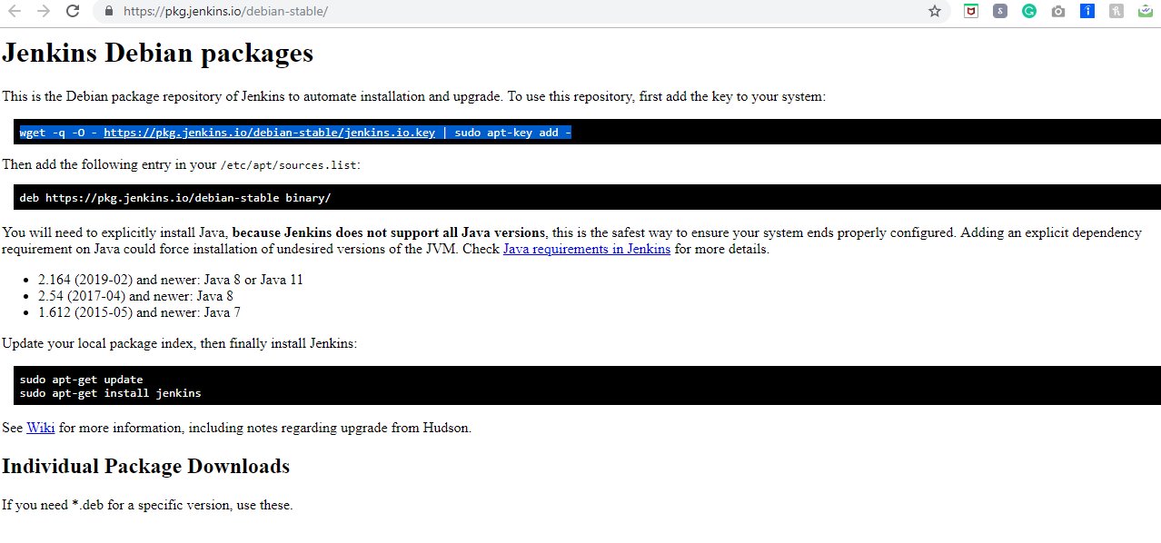

**Step 1:**

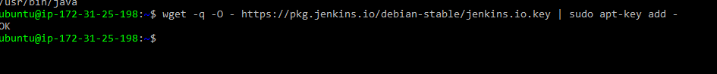

**Step 2:**

**Add the** deb [https://pkg.jenkins.io/debian-stable binary/](https://pkg.jenkins.io/debian-stable%20binary/)

**Into sudo vim /etc/apt/sources.list (at the end)**

**Step 3:**

**Update because you did the changes on source.list --- (check the line 5-8 )**

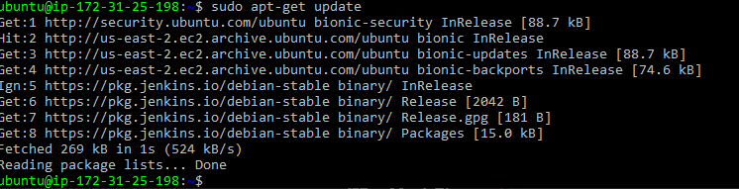

**Step 4:**

**Now install the Jenkins:** sudo apt-get install jenkins

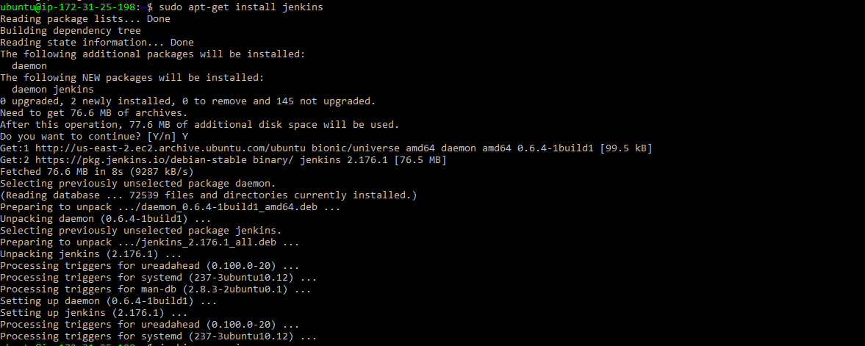

**Step 5: check the status of Jenkins: service Jenkins status (1st way)**

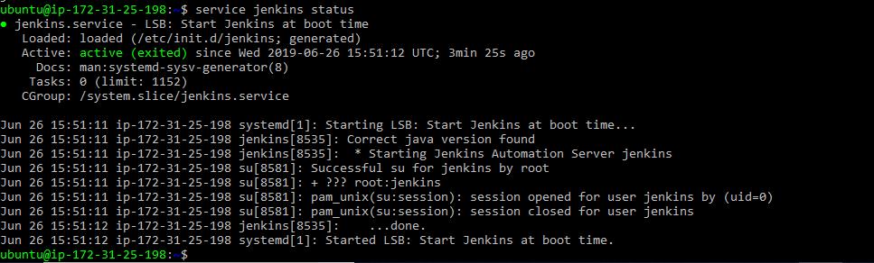

**Systemctl status Jenkins (2nd way)**

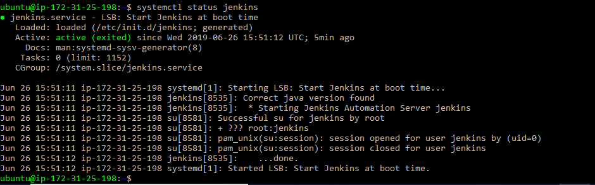

**Check you application is running or not using curl on certain port:**

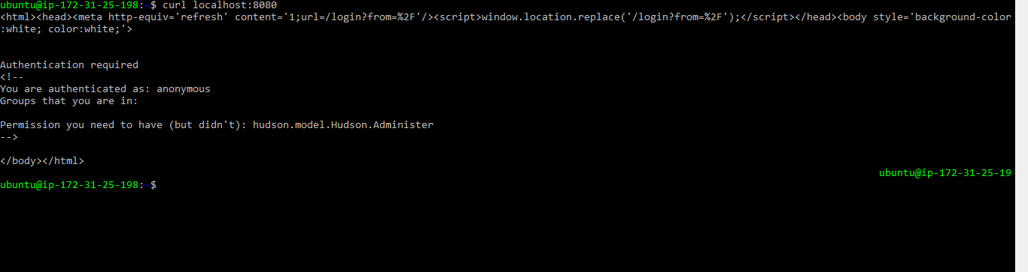

**Take you public IP address and port to get the Jenkins getting started page:**

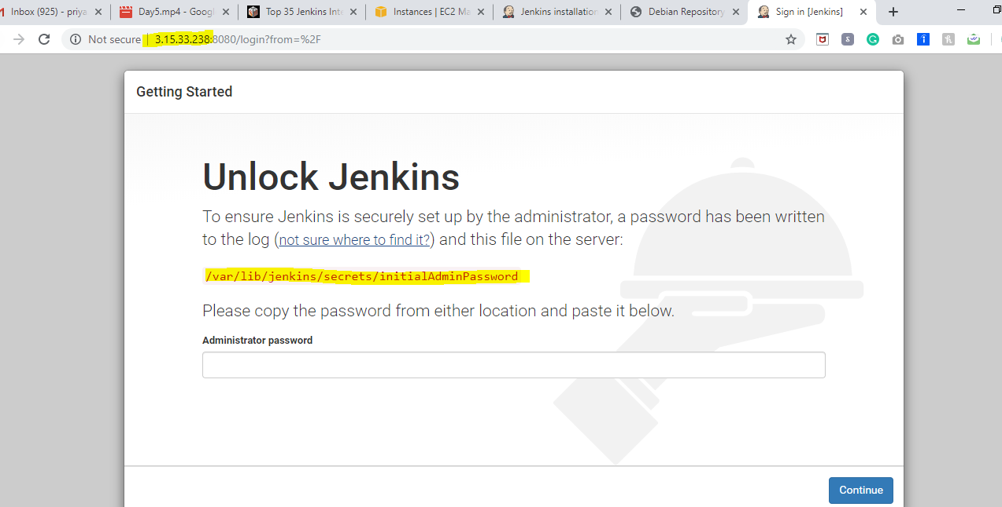



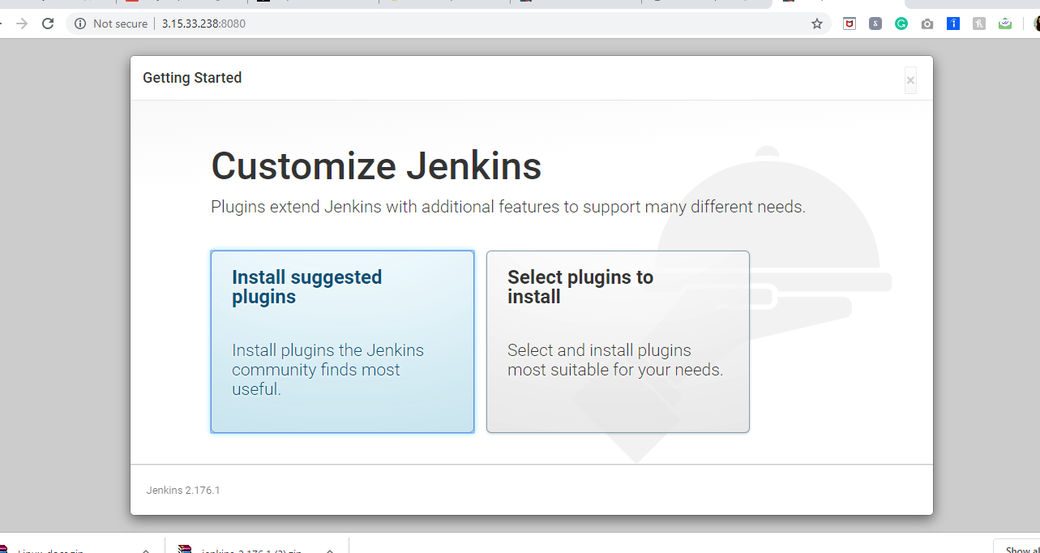

**Create your first account on Jenkins:**

**Userid: priyagup**

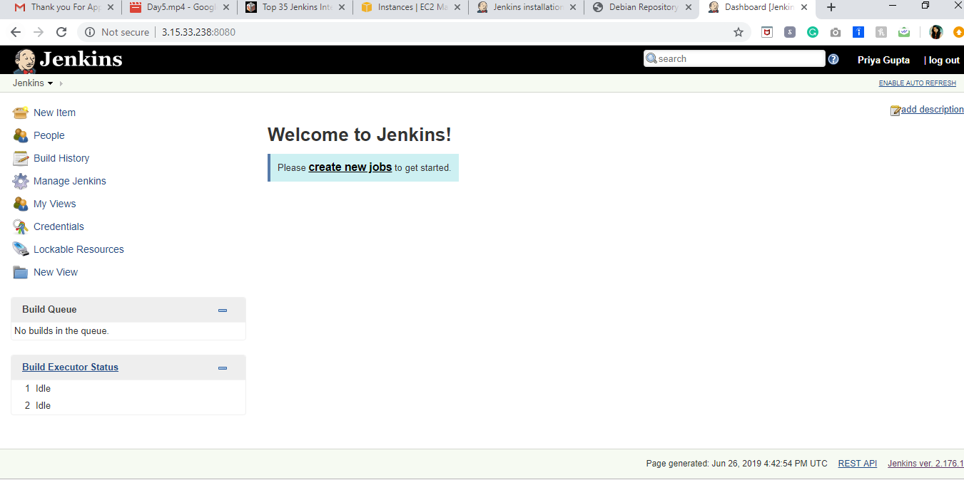

**Manage Jenkins:**

**Reload Configurations: Do migration of Jenkins (one version to another version)**

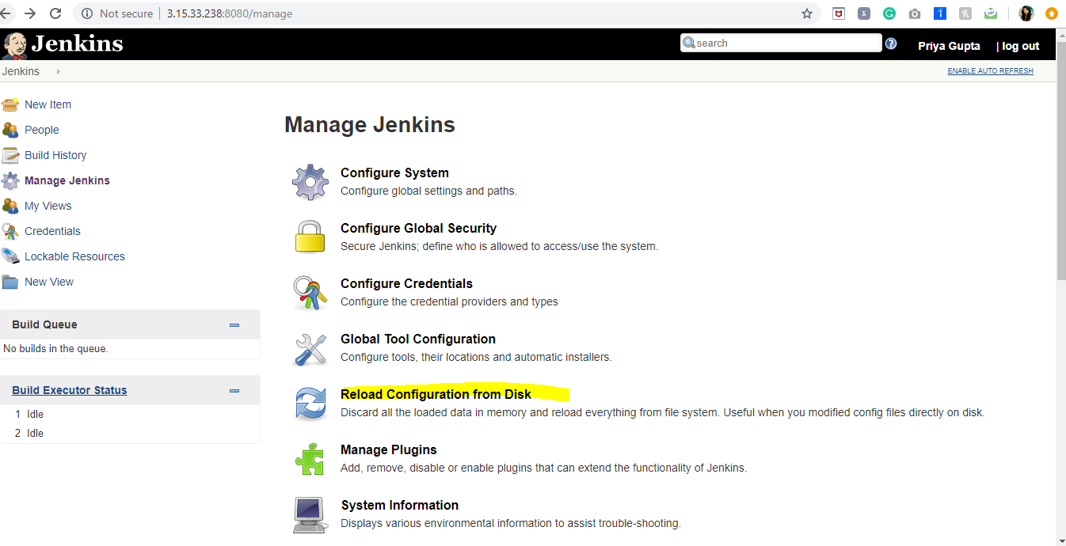

**Local directory where Jenkins store their plugins:**

**Default directory is /var/lib/jenkins**

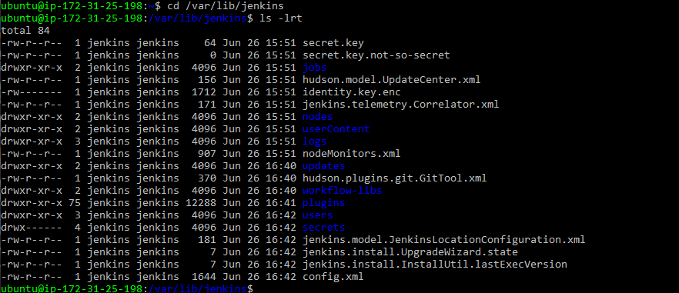

**Before creating the jobs, we don’t have anything in the folder:**

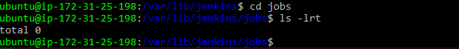

**So, to create jobs:**

**Global tool configuration:**

1. **Git**
2. **Maven**
3. **Jdk**
4. **Gradle**
5. **Docker**
6. **Ant (like maven – a build tool)**

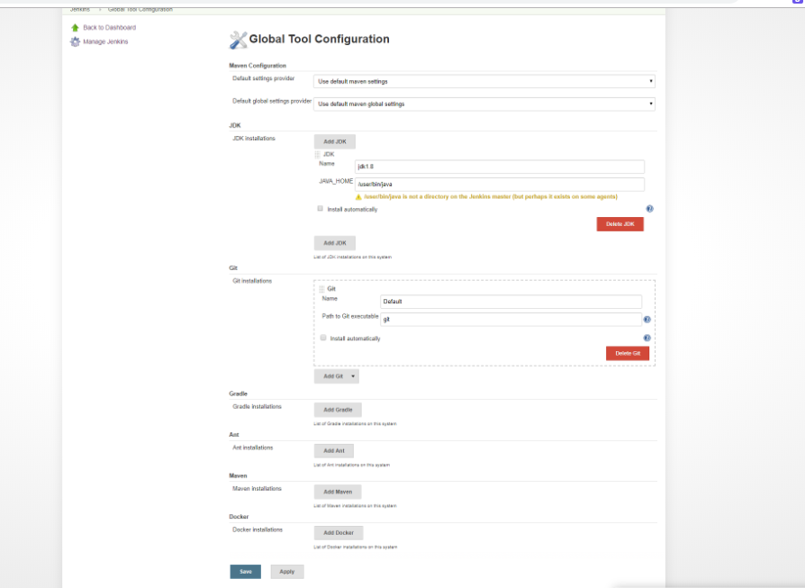

**How to Install Maven:**

**Sudo apt polity maven**

**Sudo apt-get install maven**

**How to change the java_home , after this error : update-alternatives –config java.**

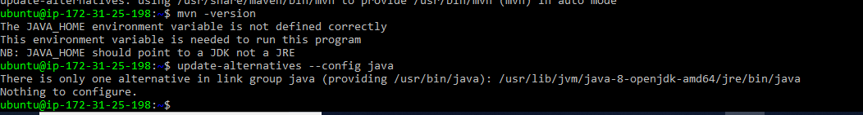

**How to run command under vim? Using “:!” command (eg- “:! update-alternatives –config java” ) copy the path and save it the file (:wq)**

**But by adding the above alternative path we are getting the same error. So I changed it**

**sudo vim /etc/environment** 

**And ran the source /etc/environment**

**mvn -version**

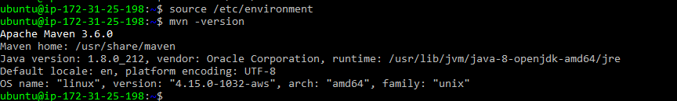

**Building my own project using Jenkins:**

**Step 1: Initializing git on eclipse folder:**



**Step 2: Check (.git) folder**

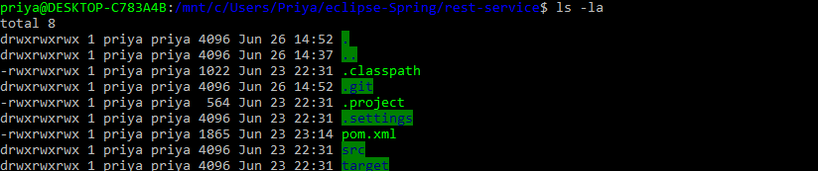

**Step 3: Check the status**

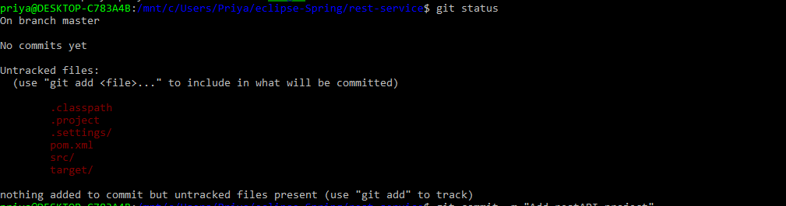

**Step 4: Add all the folders as file in red using command~$ git add . and check the status it should become green. Next write git branch.**

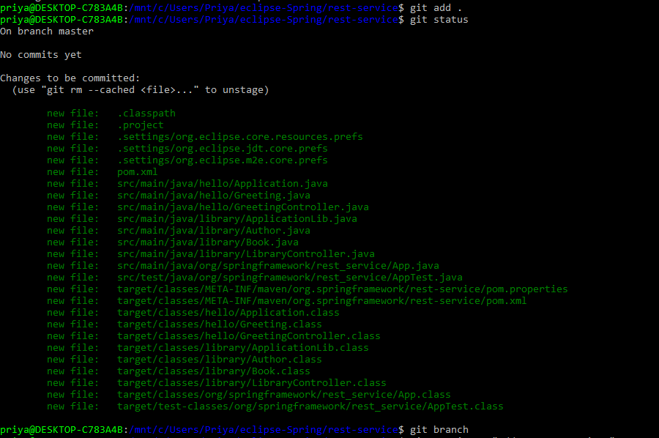

**Step 5: Finally commit**

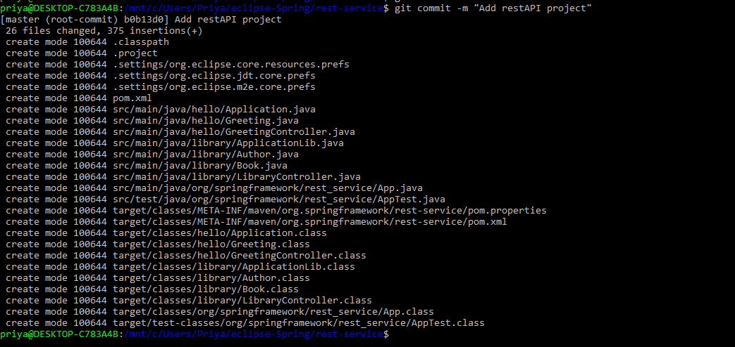

**Step 6: Add this to remote origin (link of the repository in github). And push that into master branch**

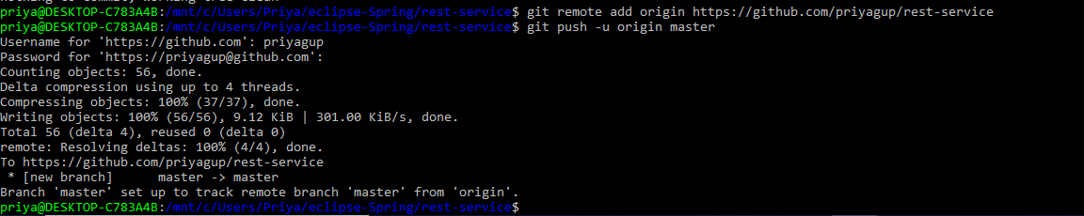

**Now I will use this github link to create the new item in jenkins**

<https://github.com/priyagup/rest-service>

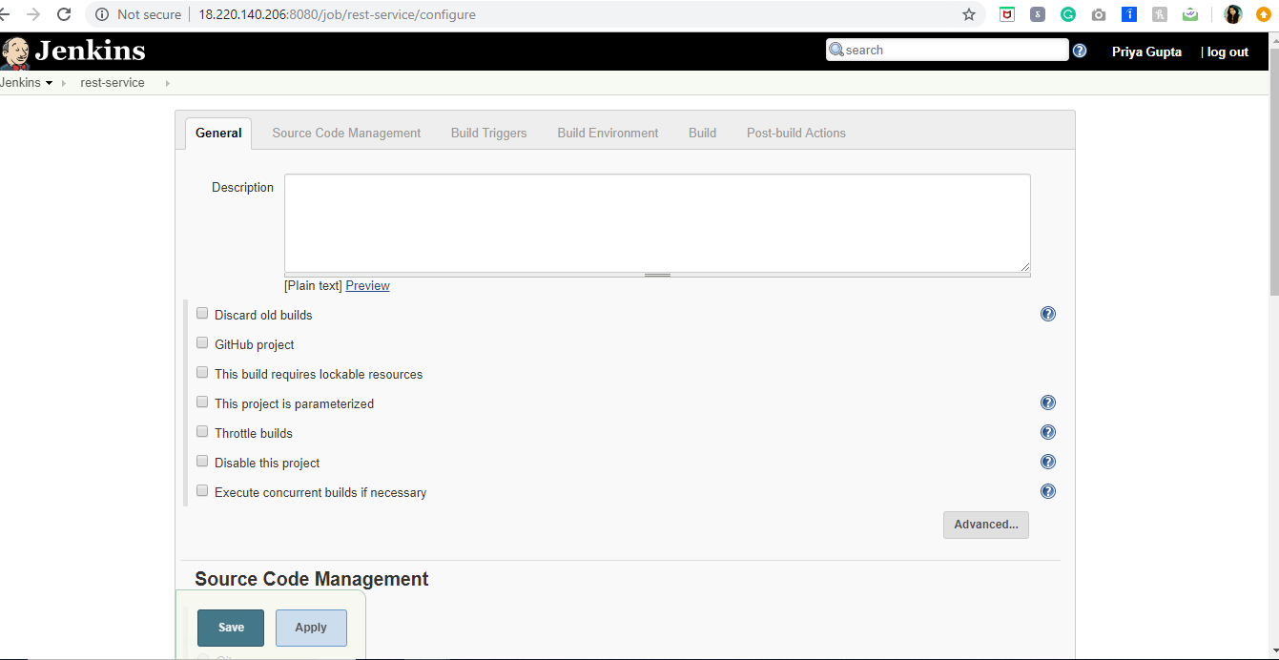

**Added the git link**

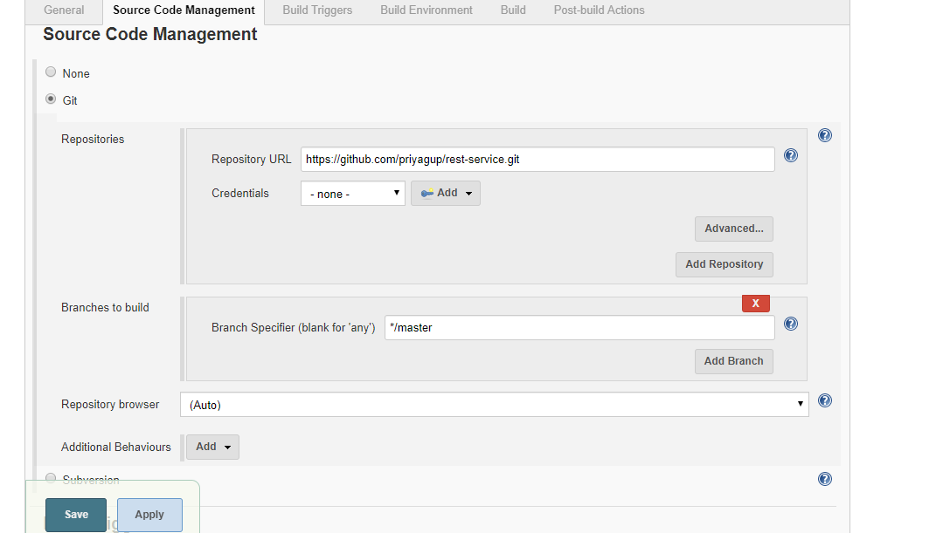

**New Build created:**

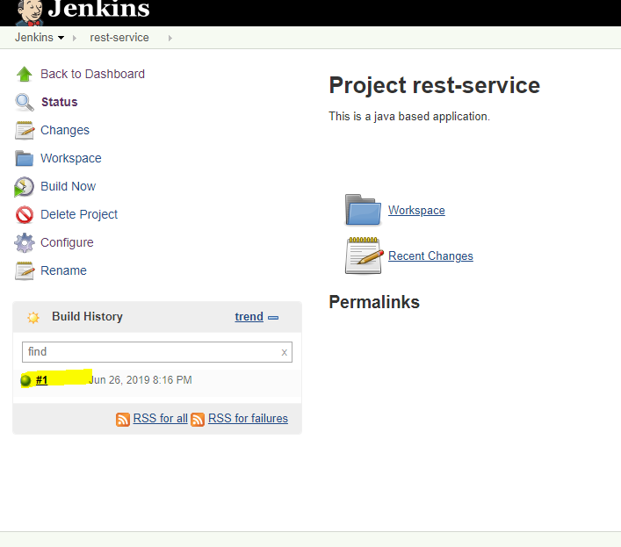

**To check new repository / workspace folder : one folder is created with same job name:**

